Moth Stories for Students
All images are from The Moth and my listed on my Playlist

Pastels and Crayons - Aleeza Kazmi
Elementary school - girls - identity, color of skin portrait

YouTube Video

Walking Together - Truly Johnson
Middle School - girl - making friends

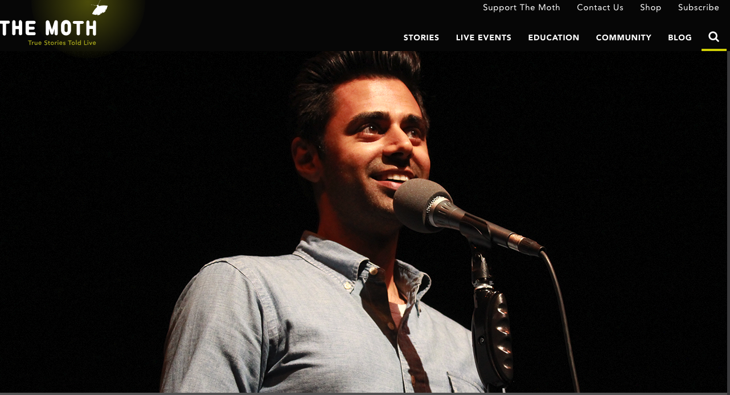 | Always Her Hasan-Bhai - Hasan Minhaj  High School - boy - prejudice & cultural expectations
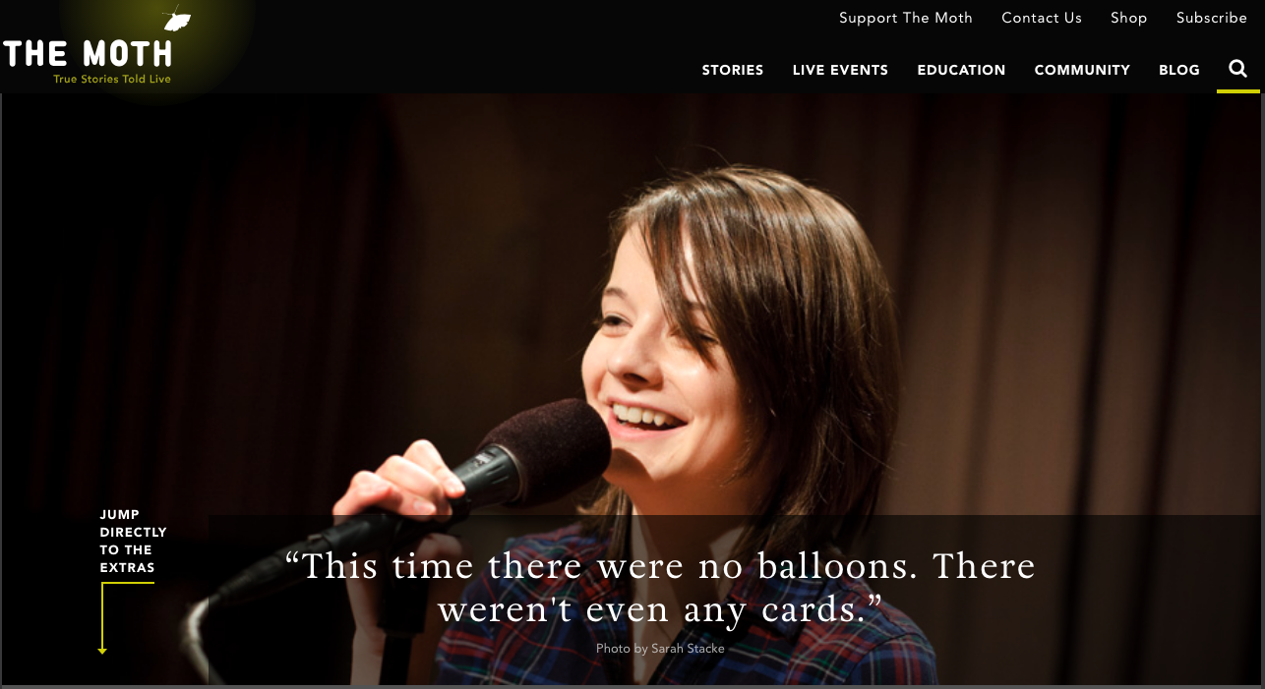 | Good News vs. Bad News  Middle School - girl - parents getting divorced because of cheating
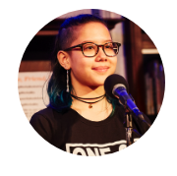 | Wild Women and Dancing Queens - Alexis Chin  Camp - high school - belonging  Written Story on Teen Vogue

The Prom
Dante Jackson comes out of his shell at his 8th grade prom.

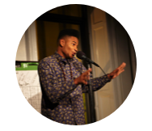 | The Bad Haircut  Alfonso Lacayo is a theater major at DreamYard Preparatory School in the Bronx. He has been participating in The Moth at DYP since spring of 2013.  Watch on YouTube

Pool Party
David Lepelstat is convinced of his superhero powers until they get him into a deadly situation.

Okay To Tell
by Emely Recinos
Emily Recinos struggles with her diminishing eyesight.

Purple Hair
by Diamante Ortiz
Diamante Ortiz brings a vibrant change to her look ad life

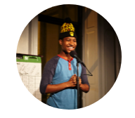 | My Grandfather's Shoes  by Christian Garland  A preacher's kid steals collection plate money from his grandfather.
Mushroom Turned Bear

by Diavian Walters
Diavian Walters has a relationship with hair that is shear madness.

First Kiss
by Eve Engel
Eve Engel hopes to get her first kiss while on a Jewish heritage trip.

Legacy by ​Anagha Mahajan
Anagha finds a creative solution to stay out of the summer heat.
Link

Truth-ache by ​Anagha Mahajan
Anagha Mahajan has a biking accident and ends up in the ER. LINK

My Left Eye by ​Anagha Mahajan
Anagha Mahajan tries to correct an eye problem with an inspirational poster. LINK
Moth High School SLAM
Students do 1 minute excerpts from their stories.

Watch on YouTube

